Name : Yash Raj
Roll Number : 24k-0737
Task#1:
Code:
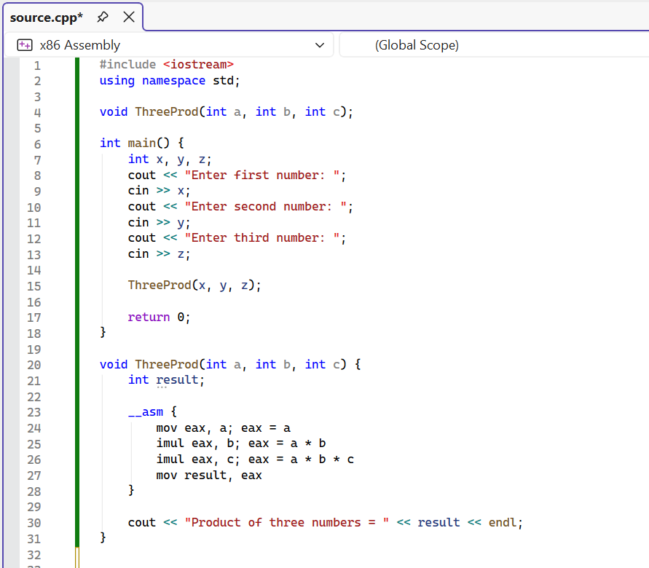

Output:
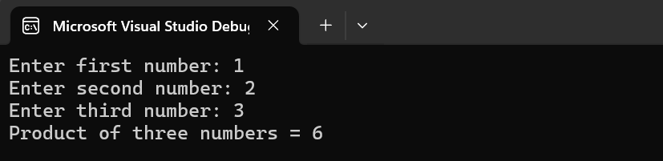
Task#2:
Code:
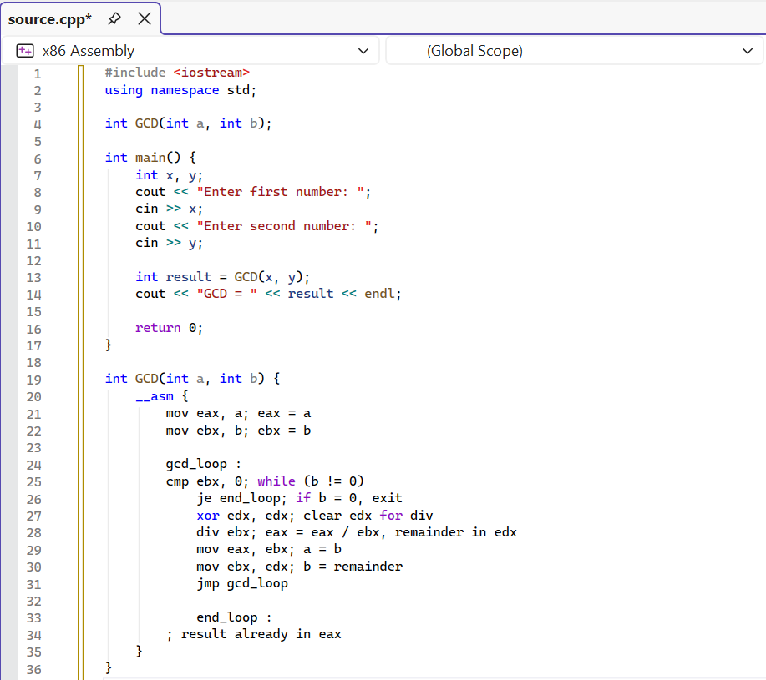
Output:
